5.5 Evaluation of Alignment with Human Expert Annotations

In Table 4, we conducted an evaluation of model generated ECG reports from ECG instruction-tuned versions of LLaMA-2 and LLaMA-3 against 500 ground-truth reports, meticulously annotated by human medical experts. These test annotated data were randomly sampled from the PTB-XL dataset, with all selected reports carefully reviewed and validated by human experts. Each model-generated report was compared with these expert-annotated reports using gpt-4o3 , which assessed quality across four dimensions: Medical Terminology Accuracy, Logical Consistency, Completeness, and Diagnostic Accuracy, on a scale of 1 to 5. To evaluate these reports, we employed the following prompt template, which guided GPT-4o’s scoring process across the defined dimensions, as shown in Table 6 in Appendix. This prompt template ensures that GPT-4o evaluates the reports in a structured and consistent manner, highlighting both strengths and weaknesses of the model-generated reports in comparison to human expert annotations. The results indicate that the LLaMA-3 model, with an average Diagnostic Accuracy score of 3.85, closely matches the quality of the human expert annotations, whereas the LLaMA-2 model scored 3.60. This evaluation underscores the effectiveness of using human expert annotations from the PTB XL (Wagner et al., 2020) dataset as a rigorous benchmark for assessing the models’ ability to generate clinically reliable ECG reports.

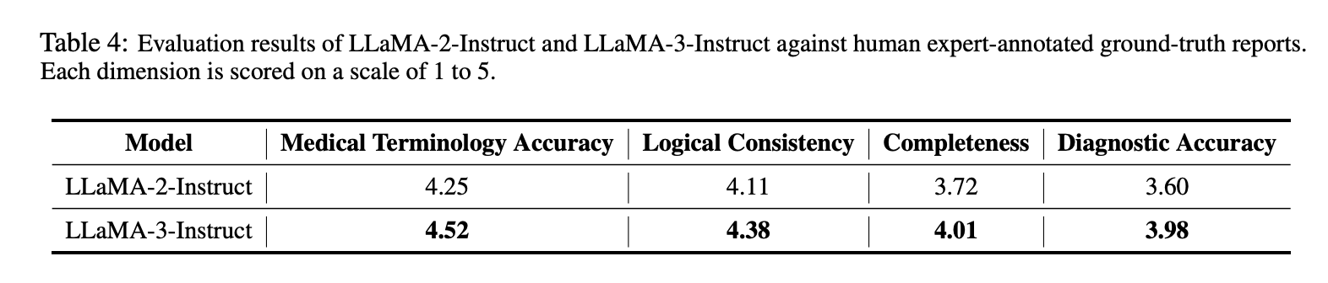

Article:
https://arxiv.org/pdf/2403.04945
July 2025

MEIT: Multimodal Electrocardiogram Instruction Tuning on Large Language Models for Report Generation

Published in ACL 2025, submitted to ICLR

Based on the Open Review feedback, several reviewers states the evalutation using multiples LLM models as a key strengths (one the top 3 strenghts)

Open review: https://openreview.net/forum?id=vFfVXSP24J
- Strenghts: The authors have conducted an extensive evaluation involving multiple LLM models.

- Many LLMs (~12 LLMs) ranging from GPT-2 models to more recent LLaMA-3-Instruct models are compared in the experiments section to assess the quality of report generation.

